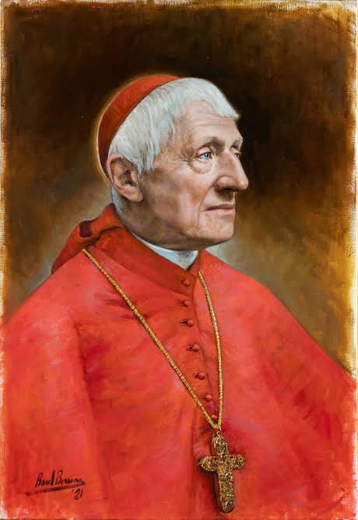
ST JOHN HENRY NEWMAN – PRAY FOR US
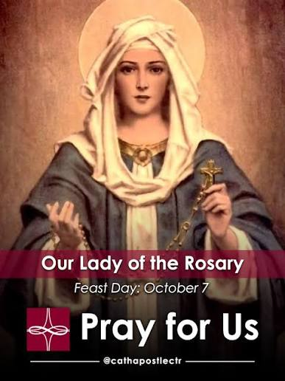
PRAY FOR US

ST ANNE’S RC CHURCH, STREETLY
26 Bridle Lane, Streetly,
Sutton Coldfield, West Midlands
B74 3HB
Email address: stanne.streetly@rcaob.org.uk
Phone: 0121 353 3778

This parish is part of the Archdiocese of Birmingham.

Registered charity No. 234216

OCT 2026 | SERVICES AND MASS TIMES | TIME | INTENTIONS
Sat 3rd Oct  Sun 4th Oct | No morning Mass  Feria in Ordinary Time  Confessions | m | Perpetuity
Sat 3rd Oct  Sun 4th Oct | No morning Mass  Feria in Ordinary Time  Confessions | 4.30pm
Sat 3rd Oct  Sun 4th Oct | FAMILY VIGIL MASS: GIFT/CARITAS/MINI VINNIES  (MESSENGER)  TWENTY-SIXTH SUNDAY IN ORDINARY TIME | 6.00pm | Paul & Julie Eborall | RIP
Sat 3rd Oct  Sun 4th Oct |  | 8.30am | People of the Parish
Sat 3rd Oct  Sun 4th Oct |  | 11.00am | Tom & Ita Cunningham | RIP`
Mon 5th Oct | Feria in Ordinary Time  Service of Word and Communion  Exposition & Prayers for Vocations in the Church | 10.00am
Mon 5th Oct |  | 10.30am
Tue 6th Oct | Holy Face of Jesus Devotions | 8.30am
Tue 6th Oct | Feria in Ordinary Time – Yr 3 in Church  Exposition and the Rosary | 9.00am | Frank Mulroy
Tue 6th Oct |  | 9.30am
Wed 7th Oct  Coffee Morning | Memorial of Our Lady of the Rosary  Exposition and Prayers for Healing | 9.00am | Ann O’Donnell & Family
Wed 7th Oct  Coffee Morning |  | 9.30am |  | RIP
Wed 7th Oct  Coffee Morning | ALPHA COURSE STARTS TODAY | 7.00pm
Thurs 8th Oct | Feria in Ordinary Time  Exposition and Prayers for Holy Souls | 10.00am | Hayley, Paolo Flonmante & Family
Thurs 8th Oct |  | 10.30am
Fri 9th Oct | Feast of St John Henry Newman, Priest  Exposition and Prayers for Persecuted Church | 10.00am | James Sutton | RIP
Fri 9th Oct |  | 10.30am
Sat 10th Oct  Sun 11th Oct | Feria in Ordinary Time - No morning Mass  Prayer & Life Group Workshop  Confessions | 11.00am  t
Sat 10th Oct  Sun 11th Oct |  | 4.30pm
Sat 10th Oct  Sun 11th Oct | FAMILY VIGIL MASS– Special Friends Mass  (INVITATION)  TWENTY-EIGHTH SUNDAY IN ORDINARY TIME | 6.00pm | Colm Walsh | RIP  RIP
Sat 10th Oct  Sun 11th Oct |  | 8.30am | People of the Parish
Sat 10th Oct  Sun 11th Oct |  | 11.00am | Baby Emmanuel Eneh | RIP  RIP
Sat 10th Oct  Sun 11th Oct |  | 12.15pm | Baptism (Rory)
SECOND COLLECTION: There is a second collection this weekend 3rd /4th October for our Building Fund. 10th /11th October is for CAFOD, 17th / 18th October is for Missio and 24th /25th October is our parish collection for Our SVP Group charity work.

COFFEE MORNING – THIS WEDNESDAY! Our Coffee Morning is this Wednesday, 7th October, from 10.00am–12 noon. Come along for good company, laughter, friendship and, of course, plenty of tea and coffee! Please note: Holy Mass will be at 9.00am on Wednesday. Come and have some fun, meet old friends and make new ones. And remember—calories don’t count when you’re sharing cake! Everyone is welcome!
ALPHA COURSE – STARTING THIS WEDNESDAY! Alpha is a welcoming opportunity to explore the Christian faith, ask questions and discover more about what it means to follow Jesus. We begin this Wednesday, the 7th of October, at 7.00pm, and we finish at 8.30pm. The course is for 9 weeks. Each evening begins with a shared meal, followed by a short video exploring an aspect of the Christian faith and time to chat and share thoughts in small groups. Whether you’re considering becoming Catholic, returning to faith, or simply looking for a refresher, Alpha is for you. Come and experience this special period of grace!
PRAYER LIFE WORKSHOP: Prayer Life Group meet next Saturday 10th October at 11am in the Parish. The session will be led by one of its members, all you have to do is come along and take part by listening and thinking about how the theme affects your own life. It’s quite uplifting.
HOLY FACE DEVOTIONS – CHANGE OF TIMES: As from Tuesday 6th October 2026, the Devotion will commence at 8.30am and should conclude by approximately 8.50am.
URGENT – MASS ATTENDANCE ON SUNDAYS: is always important, in fact, it is the First Precept of Holy Mother Church, and it is a grave sin, without just cause, to miss going to Mass on a Sunday. However, over the four weeks of the last two Sundays of September and the first two Sundays of October, it is especially important that we make every effort to attend Mass. Because these are the four weeks when we are required to count our Mass attendance and make a return to the Diocese. It is on the basis of such data that it will be decided which Churches remain open and which will close. So far, we are doing very well with our Mass attendance, let’s keep this up. I want St Anne’s to remain open! - Fr Gwil
FAMILY VIGIL MASS: Thank you to our Year 4 and Year 1 children who beautifully led our Family Vigil Mass last week. Your participation made the celebration truly special. Thank you. This weekend, we look forward to our Gift/Caritas/Mini Vinnies, with the theme “MESSENGER.” We continue to encourage all parishioners, especially our young families, to come along, support our children and help make this celebration a joyful and memorable one. Everyone is welcome!
CAFOD: There will be a stall to raise money for CAFOD on 21st &22nd November. We would be very grateful for any donations that we could sell (unwanted gifts etc). It would be amazing if any crafters out there could please consider donating an item or two, Christmas themed or otherwise. If you have ideas of crafts you could do for us, it may be possible for us to source your materials, ask Jan on 07935976241.
DIOCESAN EDUCATION SERVICE: want volunteers for their new Multi-School Academy Trust. Please see notice board for information.
DAY OF PRAYER BEFORE THE BLESSED SACRAMENT: Our next Day of Prayer is Friday 16th October 2026. Please mark the date in your diary.
STILL CALLING ON OUTDOOR UPKEEP TEAM! Our Church is a place of worship and community and a special place for all of us. Therefore, we need to take responsibility in many ways for the upkeep of St Anne’s. In the past years, volunteers have looked after the exterior grounds, but those volunteers now because of old age are no longer able to do so. I am calling on parishioners to help set up an ‘Outdoor Upkeep Team’ where we could have a rota of people to carry out little jobs once a week. If we can keep on top of these jobs, then it will keep down the cost of getting someone else in. A look around the ground will indicate the need for weeding etc. I am grateful to the person who made the courtyard nicer and with flowers etc. If you could help, please would you let Fr Gwil or Sr Lizzie know. Thank you.
OUR SVP SHOP – THANK YOU ALL! Our SVP Shop is open at weekends and on weekdays. If you would like to use the shop on a weekday, please ring the office bell and Sr Lizzie will be happy to assist. Thank you for helping us continue this work of love and service. If you are able, a suggested donation of £3 per bag will help a lot.
OUR SVP FACEBOOK: If you use Facebook, please give us a follow “SVP Streetly St Anne’s” all the likes and shares will help the SVP group reach more people. Thank you.
PARKING: parishioners, please park cars in a considerate way. By this, I mean, not parking on the pavement, not double parking to prevent emergency vehicles passing through and not to park over dropped kerbs. Thank you.

OUR PIETY STALL: We have wonderful new selection of cards and gifts for all occasions, including beautiful keepsakes for Baptism, birthdays, rosaries, holy water bottles, and much more. Thank you all for your continued support.

FORGET-ME-NOT: Our next meeting is Thursday, 12th of November, from 11.00am to 1.00pm. please join us.
ARTS AND CRAFTS: Our next meeting is on Tuesday 6th October. Everyone is warmly welcome.
POPE’S PRAYER INTENTION FOR OCTOBER – For mental health ministry: Let us pray that the mental health ministry be established throughout the Church, helping to overcome the stigma and discrimination of persons with mental illnesses.
 |  | READERS | STEWARDS
SATURDAY 3RD OCTOBER | 6.00PM | CHILDREN | PAULINE PITT
SUNDAY 4TH OCTOBER | 8.30AM | PAT O’KANE | SUSAN DE COSTA & STEPH SHANAHAN
SUNDAY 4TH OCTOBER | 11.00AM | MAUREEN PROMISE | JENNY LLOYD & SARAH BRACKETT
SATURDAY 10TH OCTOBER | 6.00PM | CHILDREN | PAULINE PITT
SUNDAY 11TH OCTOBER | 8.30AM | EDDIE HUGHES | STEPH SHANAHAN & JO CRONIN
SUNDAY 11TH OCTOBER | 11.00PM | SARAH BRACKETT | JAN SMITH & MAJELLA JUKES
SAFEGUARDING: The Parish operates in accordance with Statutory Safeguarding Guidance and the National and Archdiocese’s policies & procedures at all times. Our Parish Safeguarding Representative is Sr Lizzie. She can be contacted at: sg.stanne.streetly@rcaob.org.uk or 0121 353 3778. Alternatively, the Diocesan Safeguarding team can be contacted on 0121 230 6240/ safeguarding@rcaob.org.uk if you have any concern.

