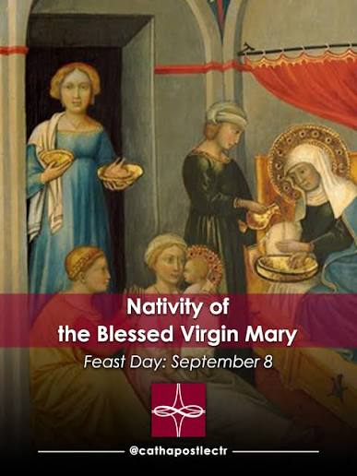

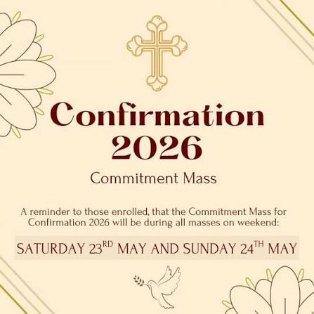

ST ANNE’S RC CHURCH, STREETLY
26 Bridle Lane, Streetly,
Sutton Coldfield, West Midlands
B74 3HB
Email address: stanne.streetly@rcaob.org.uk
Phone: 0121 353 3778

This parish is part of the Archdiocese of Birmingham.

Registered charity No. 234216
SEPT 2026 | SERVICES AND MASS TIMES | TIME | INTENTIONS
Sat 5th Sept  Sun 6th Sept | No morning Mass  Feria in Ordinary Time  Confessions | m | Perpetuity
Sat 5th Sept  Sun 6th Sept | No morning Mass  Feria in Ordinary Time  Confessions | 4.30pm
Sat 5th Sept  Sun 6th Sept | FAMILY VIGIL MASS  CONFIRMATION COMMITMENT MASS  TWENTY-THIRD SUNDAY IN ORDINARY TIME | 6.00pm | Thanksgiving for Deacon Michael
Sat 5th Sept  Sun 6th Sept |  | 8.30am | People of the Parish
Sat 5th Sept  Sun 6th Sept |  | 11.00am | Terence McGovern | 0RIP
Sat 5th Sept  Sun 6th Sept |  | 12.15pm | Baptism (Aoife)
Mon 7th Sept | Feria in Ordinary Time  Service of Word and Communion  Exposition & Prayers for Vocations in the Church | 10.00am
Mon 7th Sept |  | 10.30am
Tue 8th Sept | Feast of the Nativity of the Blessed Virgin Mary  Exposition and the Rosary | 9.00am | Jenna Lindsey
Tue 8th Sept |  | 9.30am
Tue 8th Sept | Holy Face of Jesus Devotions | 6.00pm
Wed 9th Sept | Feria in Ordinary Time  Exposition and Prayers for Healing | 10.00am | Ann O’Donnell & Family | RIP
Wed 9th Sept | Feria in Ordinary Time  Exposition and Prayers for Healing | 10.30am
Thurs 10th Sept  Forget Me Not | Feria in Ordinary Time  Exposition and Prayers for Holy Souls | 10.00am | Jose Gomez & Holy Souls
Thurs 10th Sept  Forget Me Not |  | 10.30am
Fri 11th Sept | Feria in Ordinary Time  Exposition and Prayers for Persecuted Church | 10.00am | Carmen & Maribel Ripolles
Fri 11th Sept |  | 10.30am
Sat 12th Sept  Sun 13th Sept | No morning Mass  Feria in Ordinary Time  Confessions
Sat 12th Sept  Sun 13th Sept | No morning Mass  Feria in Ordinary Time  Confessions | 4.30pm
Sat 12th Sept  Sun 13th Sept | FAMILY VIGIL MASS  YR 3 COMMITMENT MASS  TWENTY-FOURTH SUNDAY IN ORDINARY TIME  Baptism During Mass 11am (Daniel) | 6.00pm | Anne & Frank Higgins | RIP  RIP
Sat 12th Sept  Sun 13th Sept |  | 8.30am | People of the Parish
Sat 12th Sept  Sun 13th Sept |  | 11.00am | Anne & Paddy O’Reilly | RIP  RIP
Sat 12th Sept  Sun 13th Sept |  | 12.15pm | Baptism  (Gove Family)
SECOND COLLECTION: There is a second collection this weekend 5th/6th September for our building fund. 12th /13th Sept is for the Catholic Education Service, 19th /20th Sept is for The Catholic Evangelisation, 26th /27th Sept is for Fr Hudson’s Society and 3rd /4th October is for CAFOD Harvest Fast.

WEEKDAY MASSES: As our children return to school, please note a small change to our weekday Mass times. Monday’s Service of Word and Communion will remain at 10:00am. However, Tuesday Mass will now be celebrated at 9:00am to accommodate our school children who attend Mass before continuing with their studies. Therefore, our weekday Masses will generally be at 10:00am, with Tuesday Mass being the only exception at 9:00am.
PRAYER LIFE GROUP: will be meeting this Saturday 12th September at 11am in the hall. We have recently had a new member join us and thankfully they are coming back for more! It’s a very relaxed atmosphere where we talk about our faith and how it affects our daily lives. Why not come along and see what it’s all about – there’s no pressure!
OUTDOOR UPKEEP TEAM! Our Church is a place of worship and community and a special place for all of us. Therefore, we need to take responsibility in many ways for the upkeep of St Anne’s. In the past years, volunteers have looked after the exterior grounds, but those volunteers now because of old age are no longer able to do so. I am calling on parishioners to help set up an ‘outdoor upkeep team’ where we could have a rota of people to carry out little jobs once a week. If we can keep on top of these jobs, then it will beep down the cost of getting someone else in. A look around the ground will indicate the need for weeding etc. I am grateful to the person who made the courtyard nicer and with flowers etc. If you could help, please would you let Fr Gwil or Sr Lizzie know. Thank you.
EDUCATION SUNDAY - AN INVITATION FROM ARCHBISHOP BERNARD LONGLEY:
Next Sunday is education Sunday and we give thanks for the gift of Catholic education. Our schools have a mission to form Christ-centred pilgrims of hope, with kind hearts, questioning minds, a thirst for knowledge and a hunger for justice. There is a real need for more foundation directors and governors to help guide our schools and keep Christ at the heart of their mission. This is not simply an administrative role; it is a true vocation and a practical way to serve Christ and His Church. If you are a practising Catholic, committed to our mission, and willing to share your time, skills and faith, you can make a lasting difference for thousands of children and young people. No prior experience is required, as full training and support are provided. God’s unconditional love and readiness to forgive our sins remind us that service is not always easy, but it is always fruitful when rooted in love. Please speak to your parish priest or visit the Diocesan Education Service website for further details and to complete an online application form.: https://www.birminghamdiocese.org.uk/news/could-you-be-a-foundation-governor-or-director-at-your-local-catholic-school and https://www.bdes.org.uk/governor-online-application-forms.html.
COFFEE MORNING: Our next Coffee Morning is Wednesday 7th October 2026 10am – 12 noon.
FAMILY VIGIL MASS & CONFIRMATION COMMITMENT MASS: Our Family Vigil Mass has returned to normal. We welcome our school children back. This Saturday, 5th September, we will celebrate our Confirmation Commitment Mass. As always, we encourage all families to continue supporting our children in their faith.
HOLY FACE DEVOTION CONFERENCE – BIRMINGHAM ORATORY: Parishioners are invited to the Holy Face Devotion Conference, taking place at Birmingham Oratory on Friday 18th September 2026. The evening will begin with Holy Mass at 5.45pm, followed by devotions to the Holy Face. Fr Lawrence Carney is the guest preacher. Refreshments follow. See the notice board for more info.
65+ AFTERNOON TEA PARTY: Come ready to enjoy our teatime treats, live entertainment, laughter and good company on Saturday September 19th 12.30pm – 3.30pm. So, mark the date in your diary and keep yourself available! Come along, relax, and let us do the serving. It’s going to be a wonderful afternoon!
OUR SVP SHOP – THANK YOU ALL! Our SVP Shop is still open at weekends and on weekdays. If you would like to use the shop on a weekday, please ring the office bell and Sr Lizzie will be happy to assist. Thank you for helping us continue this work of love and service. If you are able, a suggested donation of £3 per bag will help a lot.
ANNUAL MASS OF THE GUILD OF SAINT STEPHEN: This will be at St Chad’s Cathedral,12noon on Saturday 3rd October 2026, celebrated by Bishop Timothy Menezes. Altar servers and their families are invited to join this year's Annual Mass of Thanksgiving for the Guild of St Stephen. Any Altar Server who is willing to attend, please could their Parents speak with Deacon Michael or Aidan – our Parish Master of Ceremony ASAP. Thank you for your cooperation.
ALPHA COURSE? The Alpha Meeting is for those who want to learn about the Christian Faith. The format of the evening is as follows: We start with a shared meal at 7pm, then at 7.30pm, there are video inputs explaining aspects of the Christian faith. These are short and then there is time between each video input to discuss, in small groups, what has been presented. The Alpha meeting will begin on Wednesday 7th October at 7.00pm to 8.30pm and will run for 9 weeks. If you are thinking about becoming a Catholic, then Alpha is for you. If you are a Catholic and need a refresher, this is for you.
PARKING: please park their cars in a considerate way. By this, I mean, not parking on the pavement, not double parking to prevent emergency vehicles passing through and not to park over dropped kerbs. Thank you in advance.
DAY OF PRAYER BEFORE THE BLESSED SACRAMENT: Our next Day of Prayer is Friday 18th September 2026. Please mark your diary.
OUR PIETY STALL: We have wonderful new selection of cards and gifts for all occasions, including beautiful keepsakes for Baptism, birthdays, rosaries, holy water bottles, and much more. Thank you all for your continued support.
FORGET-ME-NOT: Our next meeting is this Thursday, 10th September, from 11.00am to 1.00pm. please join us.
ARTS AND CRAFTS: Our next meeting is on Tuesday 8th September Everyone is warmly welcome.
ST. CHAD'S SANCTUARY: We are still awaiting info of the needs of the Sanctuary.
POPE’S PRAYER INTENTION FOR SEPTEMBER – For the care of water: Let us pray for a just and sustainable management of water, a vital resource, so that everyone may have equal access to it.
 |  | READERS | STEWARDS
SATURDAY 5TH SEPTEMBER | 6.00PM | CHILDREN | PAULINE PITT
SUNDAY 6TH SEPTEMBER | 8.30AM | JACKIE DONNELLY | SUSAN DE COSTA & STEPH SHANAHAN
SUNDAY 6TH SEPTEMBER | 11.00AM | SARAH BRACKETT | PAUL LYNAM & MATTHEW LLOYD
SATURDAY 12TH SEPT | 6.00PM | CHILDREN | PAULINE PITT
SUNDAY 13TH SEPT | 8.30AM | JOAN McLOUGHLIN | STEPH SHANAHAN & JO CRONIN
SUNDAY 13TH SEPT | 11.00AM | JENNY LLOYD | JENNY LLOYD & SARAH BRACKETT
SAFEGUARDING: The Parish operates in accordance with Statutory Safeguarding Guidance and the National and Archdiocese’s policies & procedures at all times. Our Parish Safeguarding Representative is Sr Lizzie. She can be contacted at: sg.stanne.streetly@rcaob.org.uk or 0121 353 3778. Alternatively, the Diocesan Safeguarding team can be contacted on 0121 230 6240/ safeguarding@rcaob.org.uk if you have any concern.

